At the National ecological and naturalistic center for student youth of the Ministry of Education and Science of Ukraine, we are working with children and accommodating for the circumstances in which they live, in a way to meet the needs of children at this time, wherever they are, under all circumstances. One of the ways we are doing so is by creating an educational ecological application for mobile devices based on the Android and IOS operating systems. Nowadays, more and more children are becoming environmentally conscious and want to contribute to the preservation of the environment. By creating an app that can be used by anyone, anywhere, we are empowering educators and parents to help children to continue to learn about their environment, and about science. This is what motivated us to create the "Power of EcoBubble" app.
"Power of EcoBubble" is an ecological educational and entertaining game for young naturalists and ecoactivists, which will allow players to gain knowledge of ecology in an interesting way, to acquire useful habits of caring for the environment. This is the first mobile application aimed at helping children in environmental education and education, in particular, in finding a future vocation. The game has a simple and accessible interface, which will allow children to easily navigate the game and complete tasks.
It will be interesting for young naturalists to get to know Eco Bulbashka - the main character of this game. Eco Bubble accompanies the user throughout the game, gives valuable advice and introduces the basics of environmental knowledge.
Users will be able to gain theoretical knowledge in the following areas:
• "Theory of 7 pillars",
• "Trash sorting",
• "Water use",
• "Benefits of trees",
• "Conscious consumption".
After passing the theoretical part, there is an opportunity to consolidate everything learned in game form. The efforts of users will be the key to cleaning the Planet. Eco Bubble, who knows everything about ecology, will always come to the rescue. Another feature is the availability of videos where active young people use their own example to demonstrate ways to clean the planet. This is a motivation for everyone to participate in environmental actions with friends and parents.
And finally, the game "Power of EcoBubble" will function in two languages: Ukrainian and English. For us as developers, this was one of the key tasks. After all, this will allow young users to familiarize themselves with specialized terminology, expand and replenish their vocabulary and, in general, deepen their knowledge of the English language.
We are looking forward to the launch of our app. So get your mobile devices ready and soon you will be able to download Power of EcoBubble, which we will definitely announce more!

The mobile application was created within the educational program of "Innovative technologies in the formation of environmental education" and with the assistance of Elfenworks Productions and support from The Elfenworks Foundation. We express our sincere gratitude to them for their cooperation and hope for further joint projects in the field of environmental education.

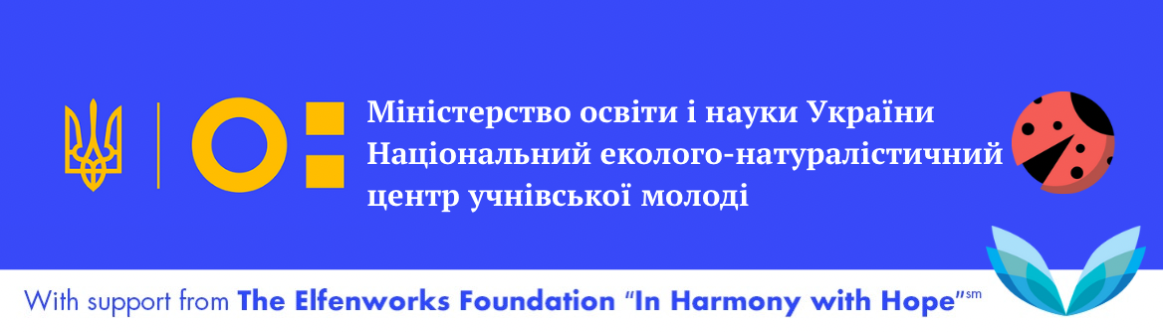

Або

